**Facebook Ads Data Analysis Assignment**

# **Objective of the Report**

This report analyzes the performance of Facebook Ads campaigns using key advertising metrics such as CTR, CPC, ROAS, Conversion Rate, CPA, and Frequency to assess campaign effectiveness and optimize future spending.

The objective of this report is to:

1. Evaluate Campaign Performance – Identify the top and bottom-performing campaigns based on key metrics, providing insights into what drives success or failure.
2. Analyze Performance Trends – Investigate high and low CTR ads, examine the impact of ad frequency, and derive meaningful insights to improve targeting.
3. Optimize Budget Allocation – Recommend how an additional ₹100,000 should be distributed among campaigns to maximize ROI while reducing spending on underperforming ads.
4. Provide Optimization Recommendations – Suggest actionable strategies to enhance ad structure, audience targeting, and creative effectiveness for improved results in future campaigns.

This report serves as a data-driven guide to making informed decisions on ad spend, campaign structure, and targeting, ensuring better performance and profitability for future Facebook Ads campaigns

# **Key Performance Indicators (KPIs)**

To assess campaign effectiveness, the following KPIs are used:

1. **Click-Through Rate (CTR)** = (Clicks / Impressions) × 100
   * Measures ad engagement—higher CTR means more compelling ads.
2. **Cost-Per-Click (CPC)** = Amount Spent / Total Clicks
   * Indicates ad cost efficiency—lower CPC is preferable.
3. **Return on Ad Spend (ROAS)** = Total Revenue / Amount Spent
   * Shows revenue earned per ₹1 spent—higher ROAS means better profitability.
4. **Conversion Rate** = (Total Conversions / Clicks) × 100
   * Reflects how well clicks turn into purchases—higher is better.
5. **Frequency** = Impressions / Reach
   * Measures ad repetition—high frequency may cause ad fatigue.

# **Campaign Performance Breakdown (Campaign Sheet)**

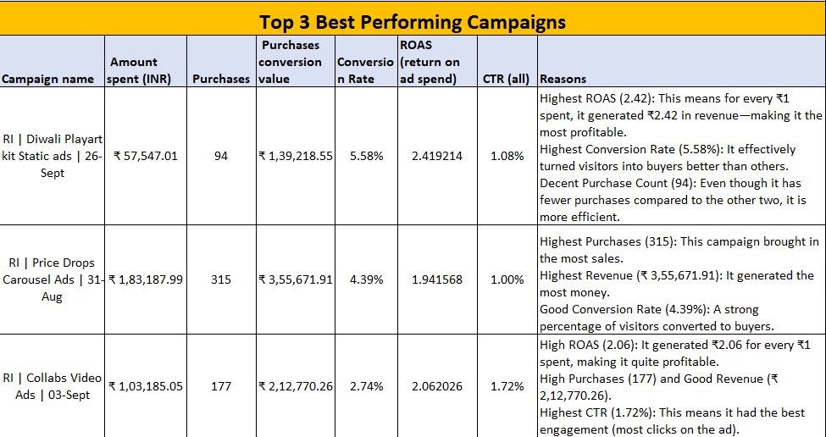

*Note-For detailed metrics, please refer to the attached Excel sheet.*

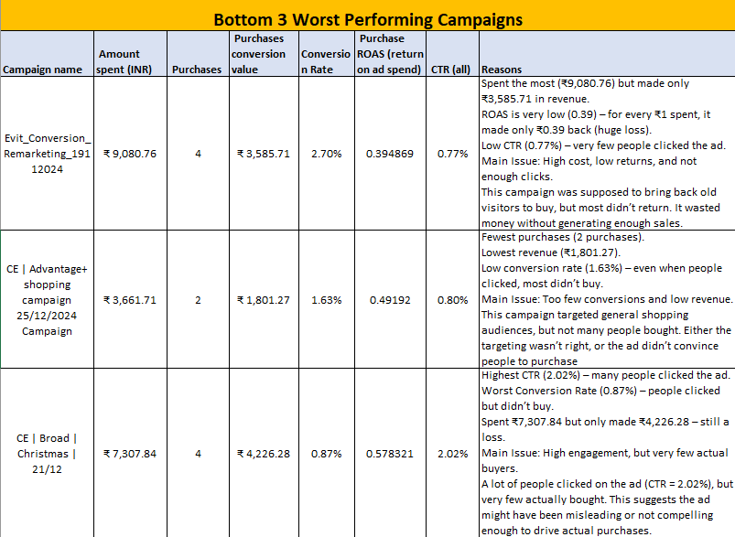

# **Budget Optimization Scenario (Campaign Sheet)**

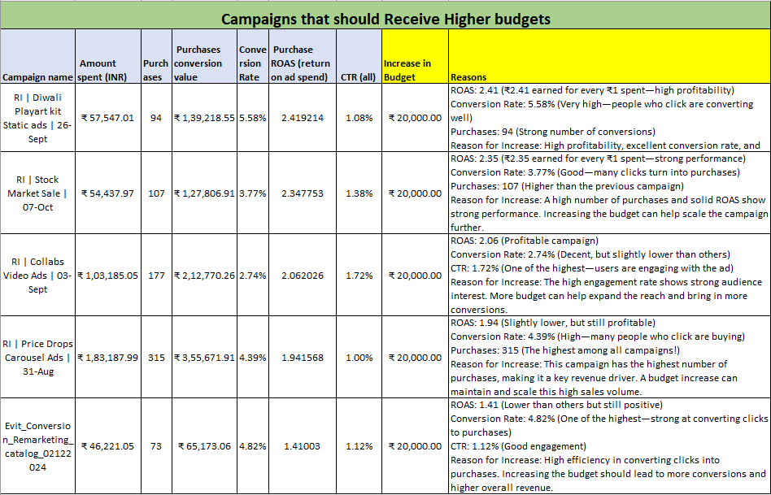

*Note-For detailed metrics, please refer to the attached Excel sheet.*

# **Budget Optimization Scenario (Campaign Sheet)**

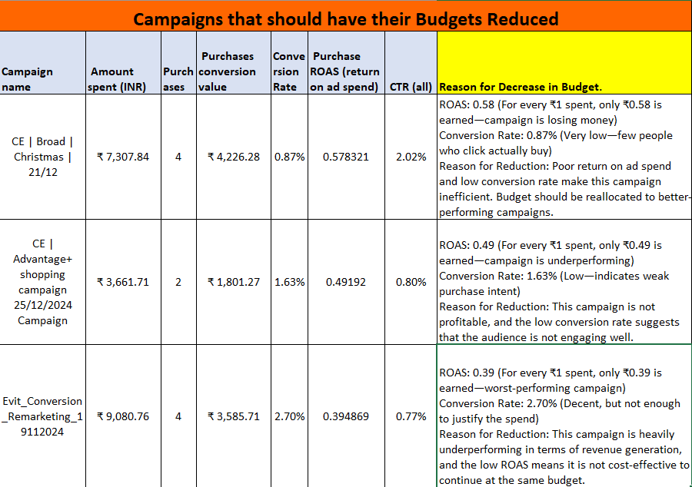 *Note-For detailed metrics, please refer to the attached Excel sheet.*

# **Performance Trends & Insights (Ads sheet)**

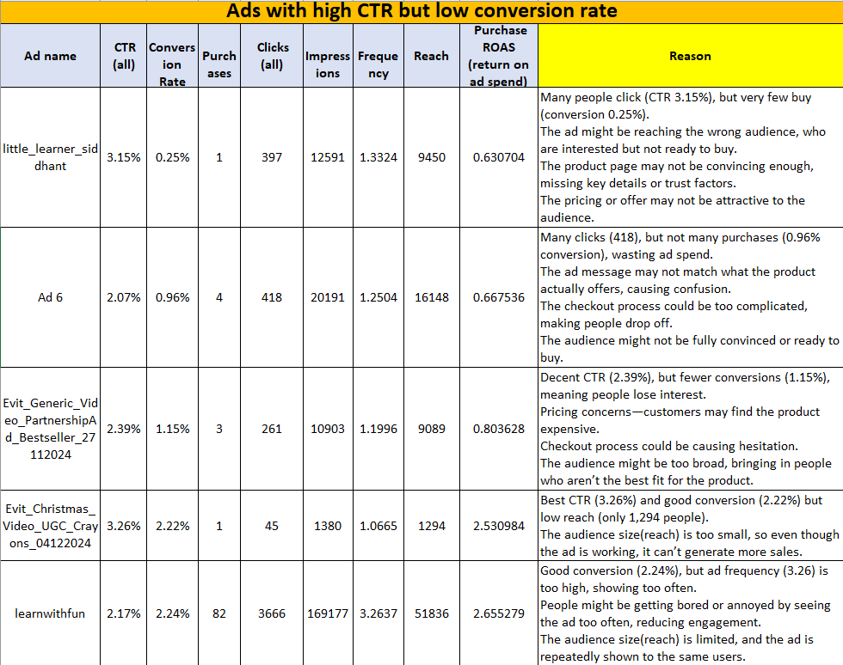

*Note-For detailed metrics, please refer to the attached Excel sheet.*

# **Performance Trends & Insights (Ads sheet)**

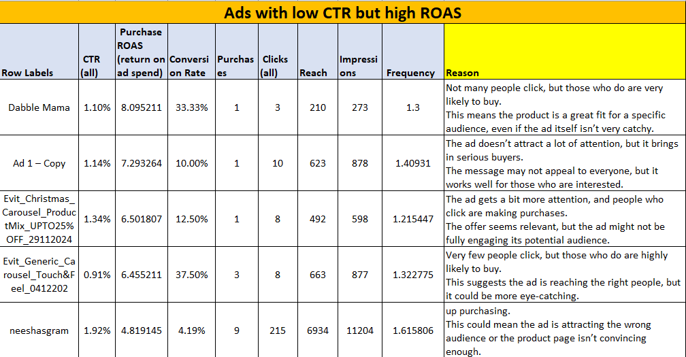

*Note-For detailed metrics, please refer to the attached Excel sheet.*

## **High Frequency Ads vs Low Frequency Ads**

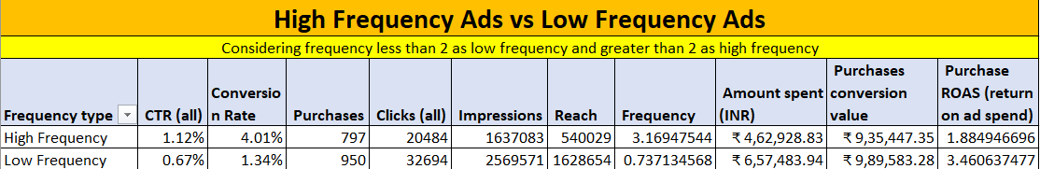

*Note-For detailed metrics, please refer to the attached Excel sheet.*

**Key Observations from the Data**

**1. Lower ROAS (Return on Ad Spend)**

* **High-Frequency Ads:** ROAS = 1.88 (Every ₹1 spent generates ₹1.88)
* **Low-Frequency Ads:** ROAS = 3.46 (Every ₹1 spent generates ₹3.46)  
  **Conclusion:** High-frequency ads yield lower revenue per rupee spent compared to low-frequency ads.

**2. Lower Conversion Rate**

* **High-Frequency Conversion Rate:** 4.01%
* **Low-Frequency Conversion Rate:** 1.34%  
  **Conclusion:** Although high-frequency ads have a better conversion rate, their lower ROAS indicates that the cost of repeated impressions outweighs the benefits.

**3. Higher Cost & Lower Reach Efficiency**

* **High-Frequency Ads:** ₹4,62,928.83 spent, reaching 5,40,029 users
* **Low-Frequency Ads:** ₹6,57,483.94 spent, reaching 16,28,654 users  
  **Conclusion:** High-frequency ads cost less but reach significantly fewer people, leading to ad fatigue—where the same audience repeatedly sees the ads with diminishing returns.

**Final Verdict**

* **Low-frequency ads are more effective**, generating higher revenue (ROAS) and reaching a larger audience at a lower cost.
* **High-frequency ads are underperforming**, as repeated exposure does not significantly boost revenue.

**Recommendation**

Reduce spending on high-frequency ads and allocate more budget to low-frequency, high-ROAS campaigns to improve profitability.

# **Optimization Recommendations (Campaign sheet and ad sheet both)**

**Ads to be Paused or Restricted**

1. **Ads with 0% Conversion Rate, CTR, and ROAS**
   * These ads failed to generate any engagement, clicks, or returns. Since they did not contribute to conversions or revenue, continuing to run them would be a waste of ad spend. Such ads should be paused or restructured with better targeting and creatives.
2. **Ads with 0 ROAS but Clicks (CTR > 0%)**
   * These ads are receiving clicks but failing to generate any revenue. This indicates that while they may attract user interest, they are not converting into sales. Possible reasons include weak landing pages, irrelevant audience targeting, or ineffective ad messaging. These ads should either be optimized or paused to prevent unnecessary spending.
3. **Ads with 0 Frequency**
   * If an ad has a frequency of 0, it means it has not been shown to users at all. This could be due to targeting issues, budget constraints, or bidding inefficiencies. These ads should be either re-evaluated or paused to avoid running ineffective campaigns.
4. **Ads with Poor Performance Metrics (Conversion Rate < 1%, CTR < 1%, ROAS < 1.0)**
   * Ads that underperform across key metrics indicate low audience engagement, poor ad placement, or ineffective creatives. Such ads are not cost-effective and should either be restructured with better optimization strategies or discontinued to allocate the budget to higher-performing campaigns. The detailed explanation is as shown below

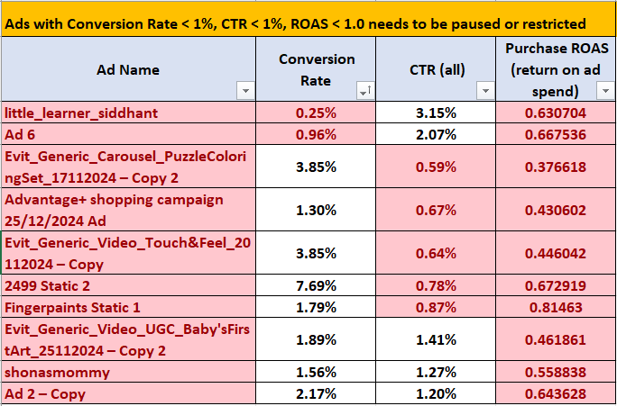

*Note-For detailed metrics, please refer to the attached Excel sheet.*

**Determining Thresholds for Low-Performing Ads**

The benchmarks for identifying low-performing ads (Conversion Rate < 1%, CTR < 1%, ROAS < 1.0) are based on industry standards and practical experience in digital advertising. These thresholds help assess ad effectiveness and guide optimization efforts.

1. **Conversion Rate < 1%**
   * **Industry Standard:** A strong Facebook ad conversion rate typically falls between 2-5% for e-commerce.
   * **Why It’s Low-Performing:** If an ad converts fewer than 1% of clicks into purchases, it indicates poor effectiveness in driving sales and should be optimized or discontinued.
2. **Click-Through Rate (CTR) < 1%**
   * **Industry Standard:** A good CTR for Facebook ads ranges between 1.5% and 3%, depending on the industry.
   * **Why It’s Low-Performing :** A CTR below 1% indicates that the ad is not engaging enough, meaning users are scrolling past without clicking. Since our brand is new and requires significant exposure, we are considering a CTR below 1% as a threshold for low performance. This suggests the need for improvements in ad creatives, copy, or targeting strategies to enhance engagement and visibility**.**
3. **Return on Ad Spend (ROAS) < 1.0**
   * **Industry Standard:** A profitable ROAS is typically 3.0 or higher, meaning that for every ₹1 spent, ₹3 is earned in revenue.
   * **Why It’s Low-Performing:** A ROAS below 1.0 means that the ad is costing more than it generates in revenue, making it unprofitable. Such ads should be reviewed for better targeting, messaging, or budget allocation.

**Key Insights from the Data to Improve Future Campaigns**

1. **High-Frequency Ads Have Lower ROAS:**
   * Ads shown repeatedly to the same audience (high frequency) generated less revenue per rupee spent (ROAS = 1.88) compared to low-frequency ads (ROAS = 3.46).
   * **Actionable Insight:** Reduce budget allocation for high-frequency ads and focus on refreshing creatives to prevent ad fatigue.
2. **Low CTR Ads Lead to Wasted Spend:**
   * Ads with a CTR below 1% fail to engage users, leading to fewer clicks and lower conversions.
   * **Actionable Insight:** Improve ad copy, visuals, and call-to-action (CTA) to make ads more compelling and relevant to the target audience.
3. **Manual Targeting Outperforms Automatic Targeting:**
   * Manual targeting resulted in higher ROAS and conversion rates, proving more effective than broad automatic campaigns.
   * **Actionable Insight:** Shift budget towards manual targeting with well-researched keywords and audience segmentation to improve ad efficiency.

**Recommended Changes to Improve Campaign Structure, Targeting, and Creatives**

1. **Optimize Budget Allocation Based on Performance:**
   * Increase spending on high-ROAS, high-conversion campaigns.
   * Reduce or pause low-ROAS campaigns with poor engagement and conversion rates.
2. **Enhance Audience Targeting:**
   * Use lookalike audiences to reach potential buyers similar to existing customers.
   * Exclude non-performing demographics or interests to prevent wasted ad spend.